Ultimate Obstacle Course

EQUIPMENT: 3 hurdles, 6 pylons, 3 beanbags, 3 hula hoops, stopwatch

PLAYING AREA: track or field

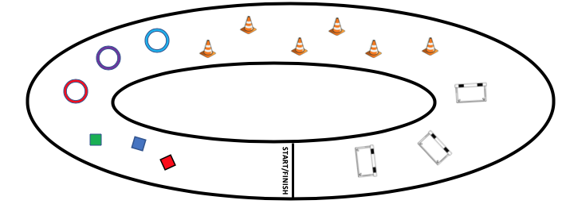

SET-UP:

- Set up the obstacle course like the diagram above.

- Organize the students into heats.

OBJECTIVE:

- Complete the obstacle course in the fastest time.

RULES:

- Crawl under the hurdles.
- Zigzag around the pylons.
- Stop and do 10 jumping jacks at each beanbag.
- Do three jumps in each hula hoop.
- Don’t cut corners.
- Don’t touch the equipment.
- Don’t touch other people.

GAME VARIATIONS:
- Add stations or change what needs to be done at each station.
- Instead of running this in heats, run it as a relay so that one student starts as soon as their teammate finishes.

Ultimate Obstacle Course

