CLIL and PE: How to teach (Academic) language during our Physical Education lessons.

The definition….Academic language refers to the language used in schools to acquire new or deeper understanding of the content and to communicate that understanding with others (Gottlieb & Ernst-Slavitt, 2013). It allows students to access content, meaningfully engage with content, and – through this process – master content (learn more here).



https://www.researchgate.net/publication/234647972_Research-Based_Recommendations_for_Instruction_and_Academic_Interventions_Practical_Guidelines_for_the_Education_of_English_Language_Learners_Book_1_of_3

Teaching Academic Language has to go beyond just presenting a word on a “Word Wall” display and calling it a day. Students need to be able to reflect on the language, grapple with it, revisit it, and have ample opportunities to apply it. Marzano actually provides a six-step process to vocabulary instruction.

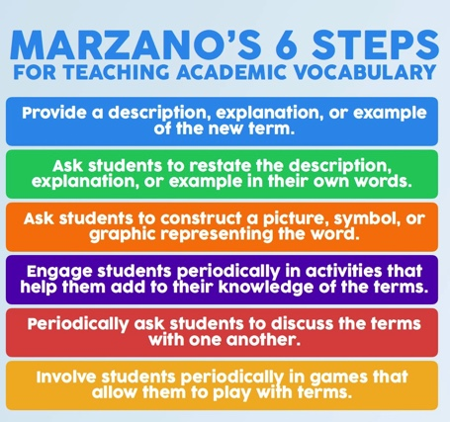

This brings us to Language Learning my Canadian PE colleague Joey Feith invented: TREK:

Language Learning TREK
- Think: Think about the new word that is being introduced. What do you already know about it? What does it make you think of?
- Read: Read the definition provided by your teacher as well as the example of the word being used in a sentence. What caught your attention? What questions do you now have?
- Explore: Explore the word by seeing how it gets used in today’s lesson. Try using it yourself in conversation!
- Know: Be confident that you now know what the word means, how to use it in conversation, and how it will help you keep moving your learning forward!

How to use this during a PE lesson?

Write this for example on the whiteboard:
Skill A skill is an action you take to complete a task or goal.
T Think about it
Working on my foot dribbling SKILL has really helped me improve the way I can move the ball up the field!
R Read the definition
E Explore as you move
K Know how to use it

Or:

Tactic An action used to gain an advantage over your opponent.
T Think about it
I couldn’t figure out how to score a point in badminton until I learned this tactic: force my opponent to move and create space that I can then attack!
R Read the definition
E Explore as you move
K Know how to use it

I think this is a structured process for purposefully introducing academic language in the PE lessons and really give a bigger meaning to the CLIL teaching during our subject.

Every lesson we want to start telling the students what the objectives of the day are and why we are learning this. We’ll finish every lesson reflecting on How we’ve learned it.

These cards hang at the whiteboards and are used by all the PE teachers.

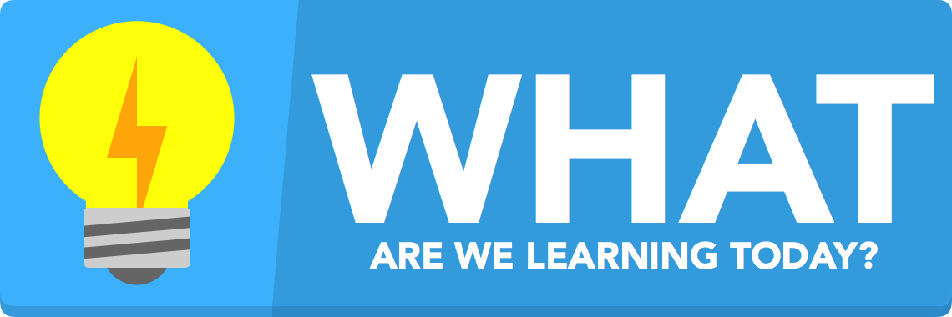

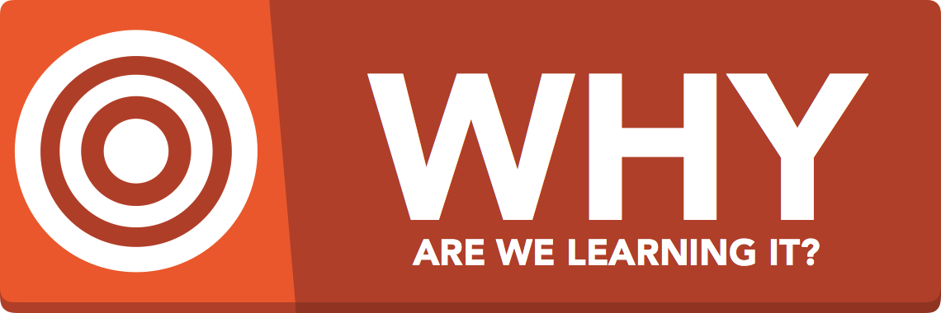



Start each lesson going over the "What, Why, How" of the day. As a class, we look over the content we will be exploring in that lesson ("WHAT are we learning today"), how it links back to the development of our physical literacy ("WHY are we learning it") and what success criteria we should set for ourselves ("How will we know we have learned it"). This process helps give purpose and meaning to each and every lesson and contributes to developing a culture of learning in the physical education classes.

Setting Up Successful Lessons with What?/Why?/How?
The “What” is the actual content of the day, our lesson’s objectives.

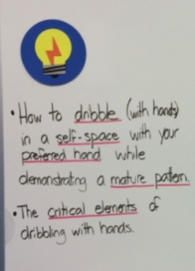

The second part of each class’ introduction is the “Why” of the lesson.
We want our students to understand the purpose behind each lesson which is why we take a minute at the beginning of each lesson to go over how mastering the day’s objectives will help in other ways outside of physical education class.
Here’s today’s “Why” portion of the board:
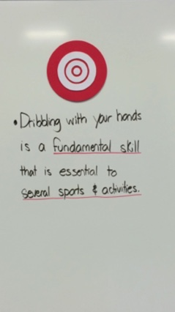
the underlined terms need to be either defined (e.g. “what is a fundamental movement skill”) or discussed (e.g. “what are examples of sports or activities where you will need to be able to dribble with your hands”).

Finally, before setting out into our activity, we go over the “How” of our lesson. We want students to have a very clear idea of how they will know they have mastered the day’s objectives by the end of class. Making them aware of this has helped my students (well… for the most part) stay focused throughout our discussions and activities in our lessons. It is very easy for students to lose sight of the learning objective once they get into the activity (unless, of course, the activity is so well designed that they need to focus on the day’s objective to be successful).

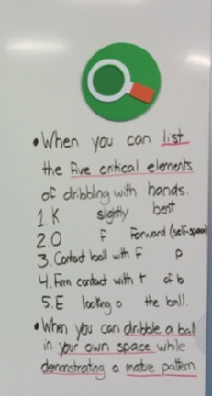
You’ll notice that I left some of the key words in the list of critical elements blank (except for the first letter). I’ve found that, with my younger students, this has been a huge help in helping them recall the items from the list during the first couple lessons in a unit (by the end, they don’t need the reminders anymore… at least not all of them).

