**SHOT PUTT TEACHING CARD**

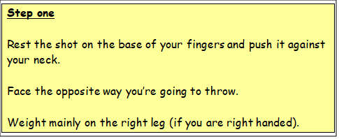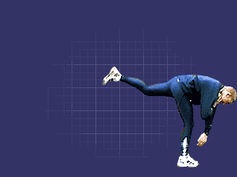

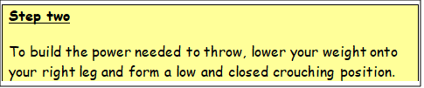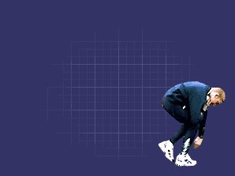

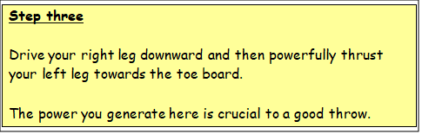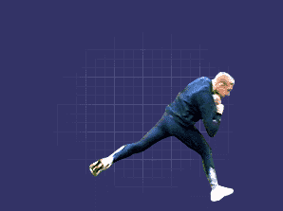

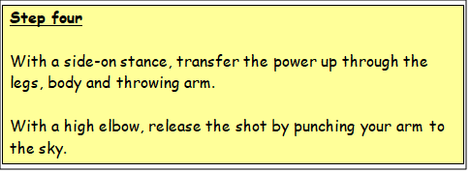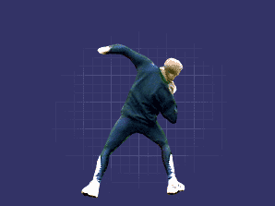

**Shot Putt Checklist**

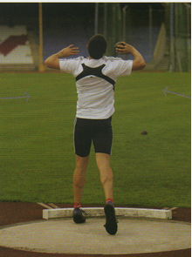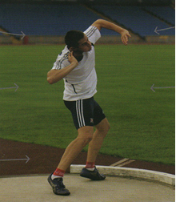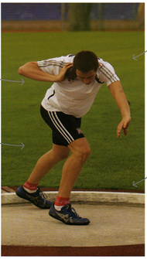Task: Watch your partner throw 3 times. Check to see if your partner demonstrates any of the following teaching points?

|  |  |  |
| --- | --- | --- |
|  | YES | NO |
| Shoulders facing away from the direction of throw? |  |  |

|  |  |  |
| --- | --- | --- |
|  | YES | NO |
| Elbow high? |  | Shape |

Shape

|  |  |  |
| --- | --- | --- |
|  | YES | NO |
| Left foot toes in line with heel of right foot? |  |  |

|  |  |  |
| --- | --- | --- |
|  | YES | ShapeNO |
| Both legs bent? |  |  |

Shape

|  |  |  |
| --- | --- | --- |
|  | YES | NO |
| Left arm kept high? |  |  |

|  |  |  |
| --- | --- | --- |
|  | YES | NO |
| Hips driven forwards and upwards? |  |  |

|  |  |  |
| --- | --- | --- |
|  | YES | NO |
| Weight transfers from right leg to left leg? |  | Shape |

|  |  |  |
| --- | --- | --- |
|  | YES | NO |
| Legs and body extend? |  |  |

|  |  |  |
| --- | --- | --- |
|  | YES | NO |
| Arm pushes long and high? |  |  |

Shape