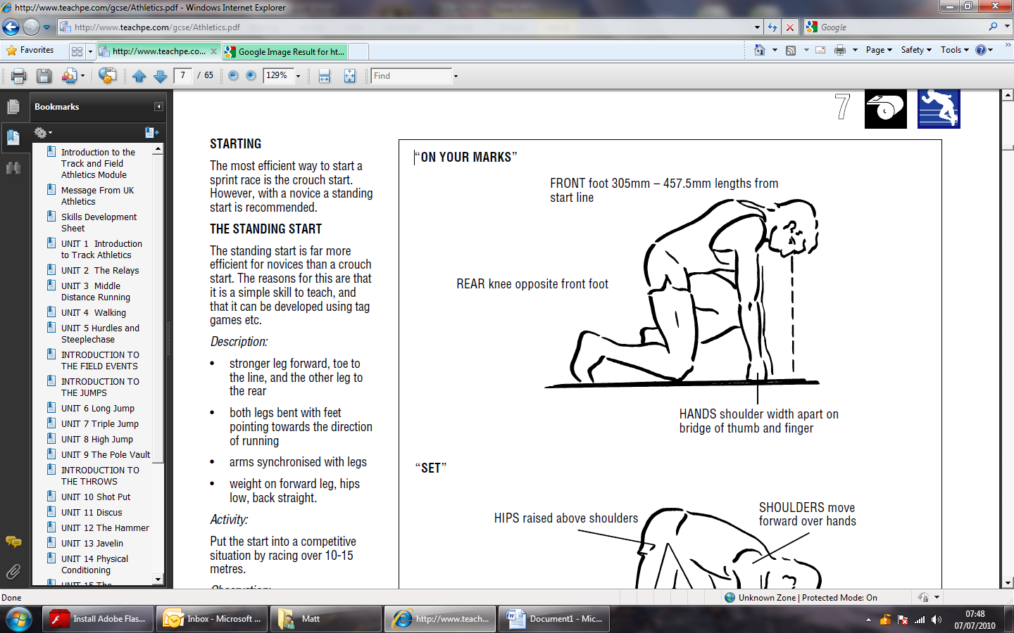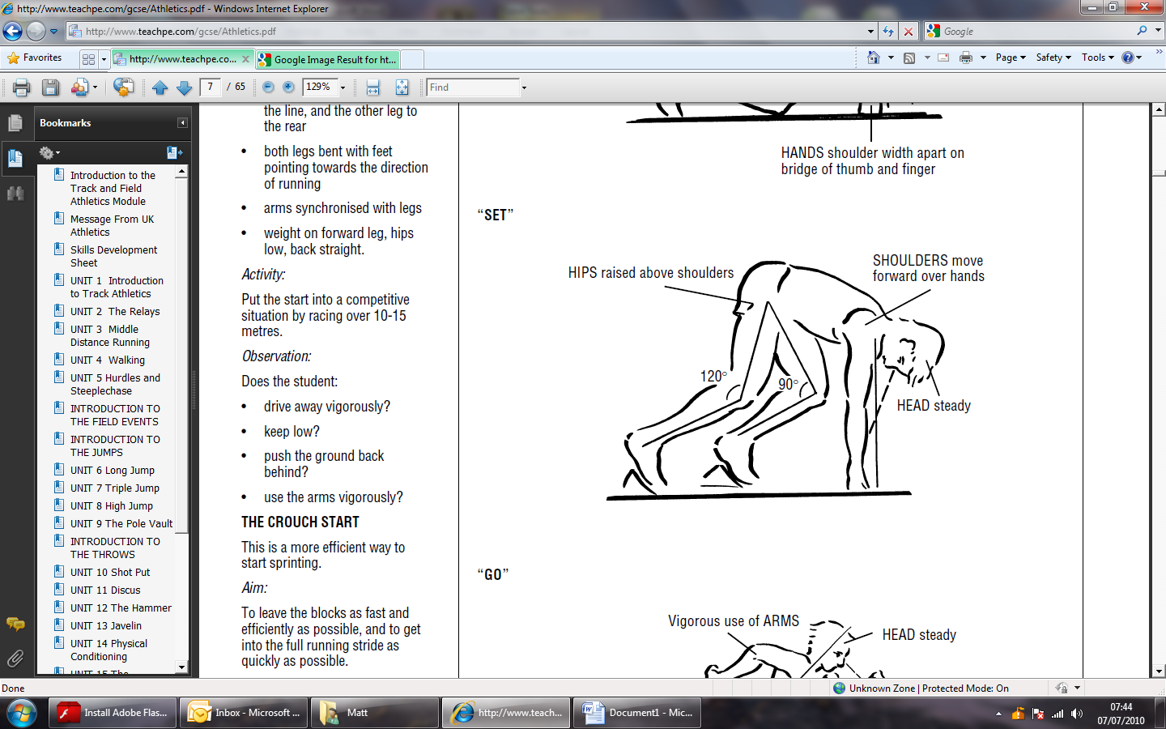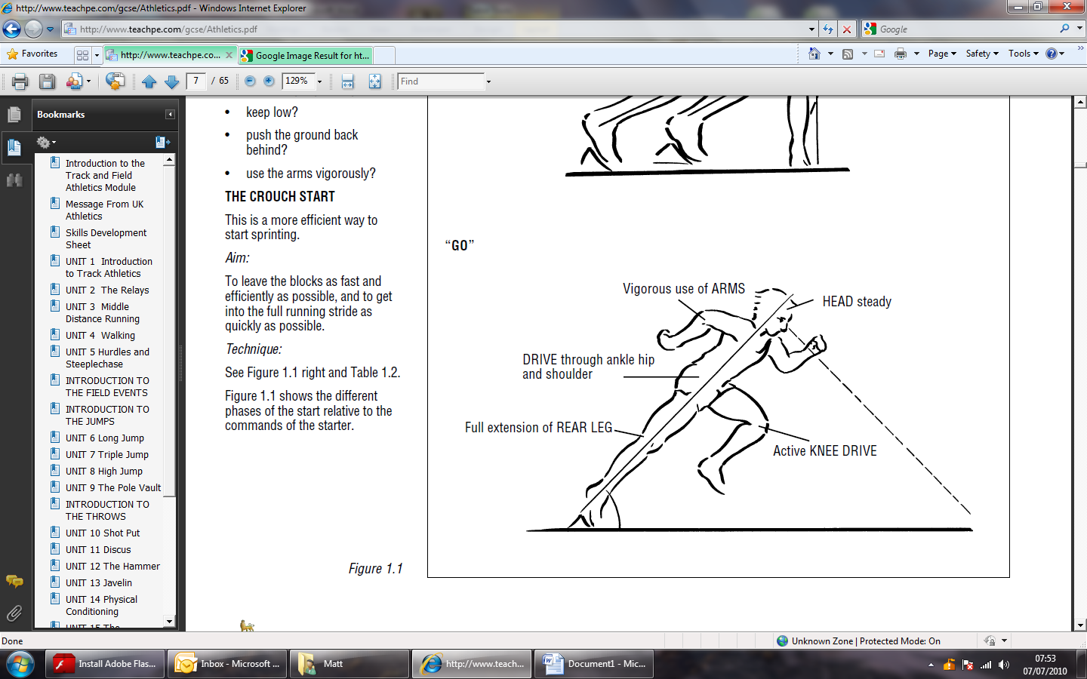The Sprint Start

Vigorous arm action (fast elbows) to get legs moving.

Drive and extend – good line from toe to head.

Drive hard off blocks and drive head and shoulders out.

Shoulders move forward and up (needs strength!).

Hips move up higher than shoulders so making correct angles at knee joints (90° front knee, 120° rear knee).

Keep head in line with spine.

Focus eyes on where first stride will land.

Shoulders directly over hands.

Place the rear knee in line with front foot.

Hands make bridge between thumb and forefinger.

Hands are placed shoulder width apart.