
Title: Grades
Type: CLIL, general, coach
Lesson Goal: Teacher can use this as an example how to give grades and use vocabulary

Instruction | information | Extra info
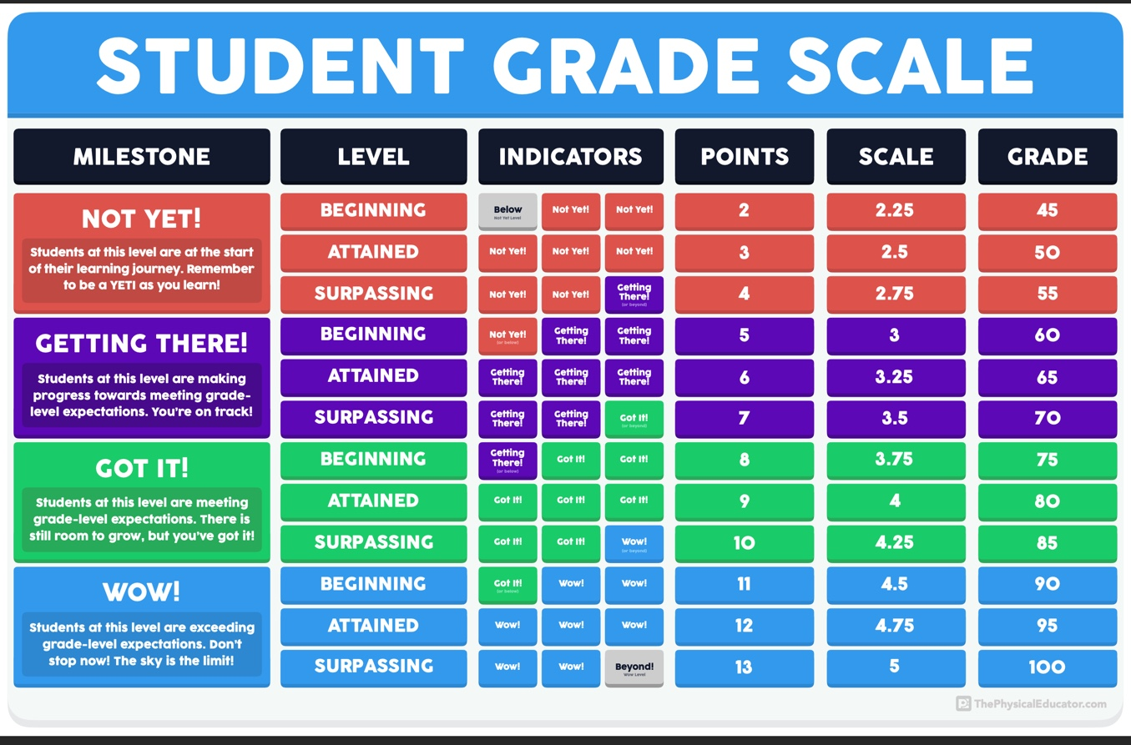  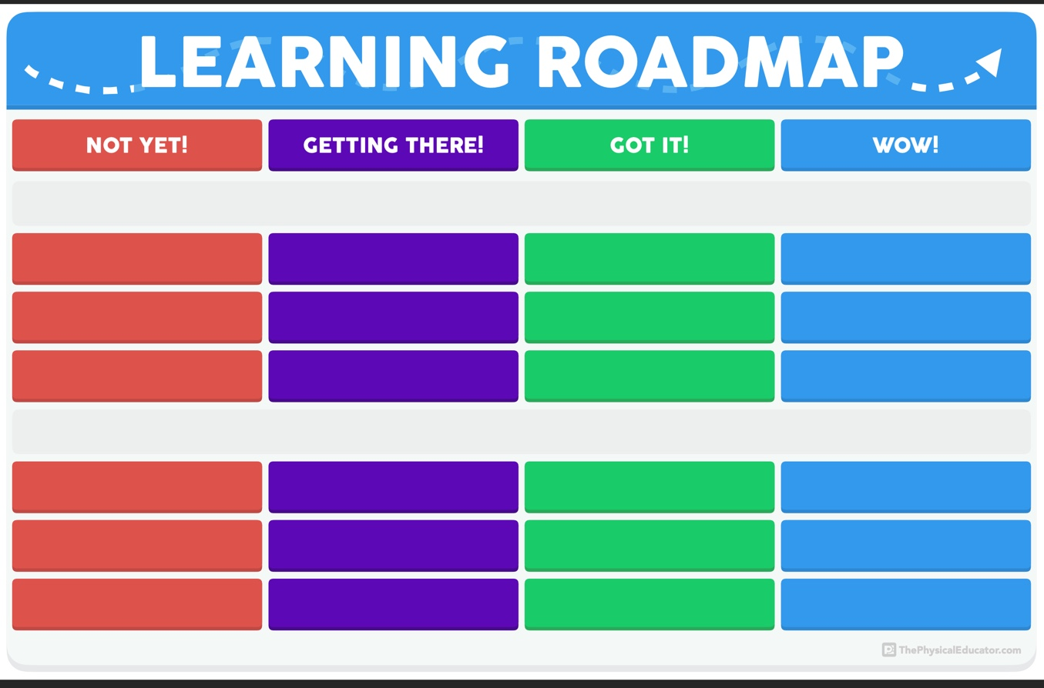 | For years, I’ve been trying to get to a place where my assessment and grading system was simple, easy-to-understand, and effective at helping my students learn. I’m confident that this is the year that I have finally cracked grading in physical education!  The Meaningful Grading System involves three tools:  🗺 Learning Roadmap  📊 Student Grading Scale  📋 Numbers Gradebook  You can learn all about this system and each of its components in this overly thorough blog post: https://thephysicaleducator.com/2019/09/15/meaningful-grades-in-physical-education  In this download, you will find the following resources:  🗺 Learning Roadmap | Blank Template (PDF)  This PDF provides you with the template for my updated Learning Roadmaps. You will need to use a PDF-editing application in order to add text boxes to the document so that you can fill in the spaces with your grade-level outcomes and GLO indicators.  📊 Student Grading Scale  This PDF provides you with my all-new Student Grading Scale. Use this document to help you quickly determine where your students are at in their learning, what they can be doing to keep moving their learning forward, and how they arrived at specific grades.  📋 Numbers Gradebook  To help get you started, I included a Numbers document (MAC/iOS ONLY) that has templated for units of one, two, or three grade-level outcomes. The formulas, VLOOKUPs, and conditional formatting rules are all good-to-go! Just copy/paste the tables you need and start assessing!  Happy Teaching!
Field set-up:

Link to support/assessment document: www.thephysicaleducator.com

Additional pages if necessary:

