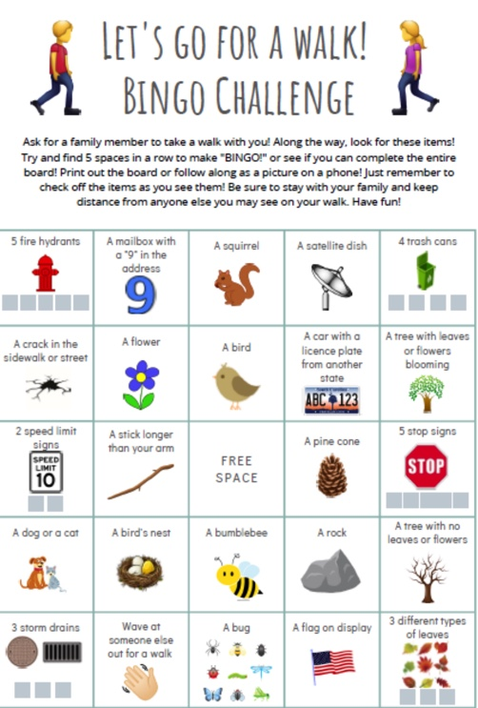

Picture and walking time!

If you feel healthy enough, go outside for a walk. Ask a family member to join you! Along the way, look for different items!

Find these items and take a picture of them.

When you come back home, edit the pictures to one frame. You can use an app for that (collage apps) or just insert them in a word document.

Upload this document at it’s learning before the end of the week and of course add a picture of yourself in it as well. We miss you and would like to see your smiling face!

These are the different items you have to find:

1. A picture of yourself while you are walking (smile! ☺ )
2. A trash can
3. A street-name sign
4. A flower
5. A bird
6. A car with a license-plate starting with a Z
7. A tree with leaves or flowers blooming
8. A stick longer than your arm
9. A dog or a cat
10. A flag