FIVE STAR KEEP AWAY FOOTBALL

EQUIPMENT: 1 soccer ball for every group of 6-8 players, 8 pylons

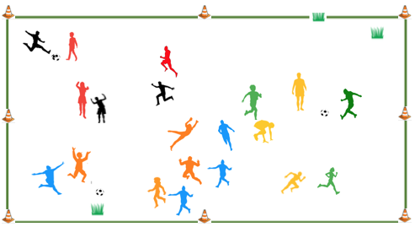
PLAYING AREA: field
SET-UP:

- Use pylons to mark the perimeter of the playing area. This should be a fairly large area to allow students to spread out.

- Divide the class into groups of 6-8 players. Within each group, there should be an even number of players.

- Subdivide each group into two teams with an equal number of players on each team. Substitute a player in if there is an odd number of players in one of the groups.

- Give each group a soccer ball.

OBJECTIVE: The objective is to pass a soccer ball to your teammates but keep it away from your opponents.

RULES:

- Even though they are sharing the same playing area, each group plays a separate game.

- You can only touch the soccer ball with your feet. No hands allowed!

- A player in each group starts with the ball. They try to complete a pass to a teammate without the other team touching the ball. If they successfully complete five passes in a row, they score a point. If they score five points, they complete a star and win the game.

- Passes must be at least 6 feet. If they are less, the defensive team takes possession of the ball.

- Players can only have possession of the ball for 5 seconds between passes. If a player has the ball for longer than that, the other team takes possession.

- Players can’t touch each other. Offensive players make cuts to get open. Defensive players try to position themselves between the passer and receiver to intercept passes.

- If a ball leaves the playing field, the last team to touch it loses possession and the other team starts a new count with the ball.

- If a team intercepts a pass, they take possession and start a new count with the ball.

- If a team completes five passes in a row, they score a point and the other team takes possession of the ball.

GAME VARIATIONS:

- Adjust the playing area for the number of players.

- Adjust the number of players on each team.

- Instead of playing to 5 points, just play for a designated length of time and the team with the most points wins.

Five Star Keep Away

