KICK DODGEBALL

EQUIPMENT: hula hoops (about 1 per student), gator skin balls (1 for every 2 students), 2 pylons, stopwatch

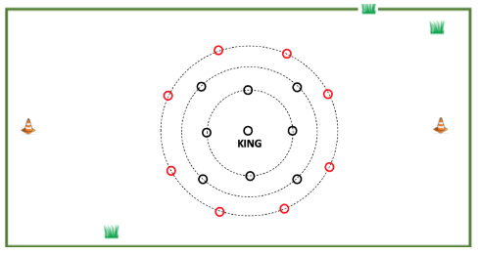
PLAYING AREA: field

SET-UP:

- Set up three rings of hula hoops similar to the diagram. Each hoop should be at least 15 feet away from any other hoop. Adjust the number of hoops in each ring where necessary to suit your class size. The hoops can be any color but are shown in the diagram as black for the defenders and red for the kickers.

- Divide the class into two teams. The king and his guards are on one team. The kickers are the other team.

- Provide a gator skin ball for every kicker.

OBJECTIVE: The objective is to hit the king with a gator skin ball.
RULES:

- You can only touch the gator skin ball with your feet. No hands allowed!

- Teams will take turns being kickers and defenders.

- The defending team chooses a king who will be in the center hoop. Guards on his team will be in the two closest rings to him as shown by the black hoops in the diagram.

- The hoops on the outside ring, which are shown as red in the diagram, are kicking hoops for the other team. Attackers may move into any of these hoops, kick a ball at the king or a guard, and then vacate the hoop for another teammate.

- When you are occupying a hoop, you must always keep at least one foot in the hoop. You can have both feet in the air while dodging a ball, but when you come down, you must land with at least one foot in the hoop.

- Guards may dodge a ball or block it to protect the king.

- If a kicker kicks a ball and hits a guard, the guard must temporarily leave their hoop, run around a pylon at either the end of the field, and return to their hoop.

- Kickers are free to roam and may shoot from any of the kicking hoops.

- A stopwatch is used to time how long it takes to hit the king. Each round of the game ends as soon as the kings is hit. When this happens, the shooting team becomes the defenders and the king and guards become kickers who try to beat the time of their opponents.

GAME VARIATIONS:

- Vary the distances between the hula hoops.

- Move the pylons closer or farther away.

Kick Dodgeball

