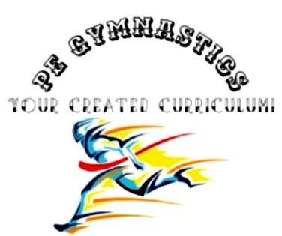
Title: resolving conflicts
Type: clil, general
Lesson Goal: how do your students deal with conflicts and how can you coach them in this.

Instruction  Given the dynamic, active, and sometimes wild nature of physical education class, it is normal for conflicts to arise. To help teach my students how to manage the conflicts they experience in a productive way, I created this Conflict Resolution Poster.  The poster breaks conflicts down into three main categories:  😕Small Conflicts  ☹️Medium Conflicts  😡Large Conflicts  Each category is provided a simple yet effective definition as well as an example of a potential conflict situation at that level and a possible conflict resolution strategy. The boxes were left blank so that you can unpack each level of conflicts with your students and think ahead by identifying your own resolution strategies for each!  Combined with the Emotional Toolbox and Conflict Corner resources, this poster has been a great help in support my students as they build their capacity to identify, make sense of, and resolve conflicts independently in class and beyond!  ================  LICENSE:  Instead of some fancy legal talk, here’s what you should know in plain English:  - This item (or any of its parts) may not be resold. You can use it in your teaching and include it in your presentations, but do not sell it as part of any product you sell without my written consent.  - This item cannot be used on merchandise for sell. I know it looks nice, but you can’t make it into a T shirt.  - This item cannot be used as a logo for your brand, site, store, etc. | Differentiation options | Extra info
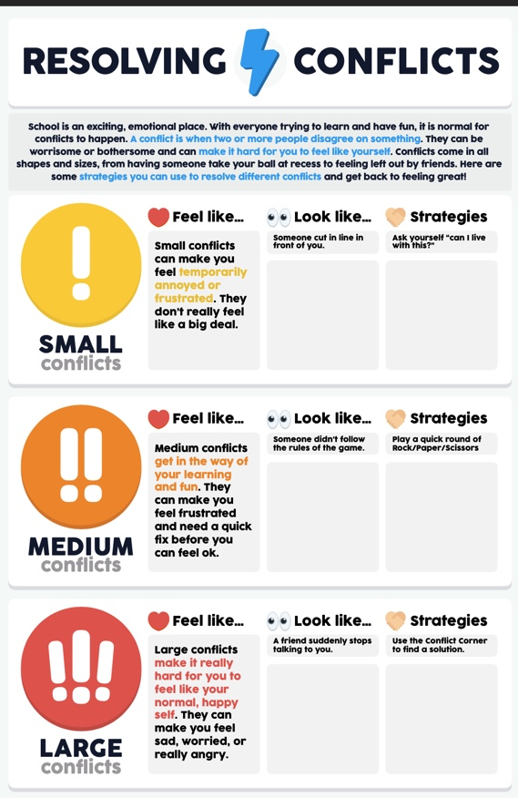
Field set-up:

Link to support/assessment document

Additional pages if necessary:

