*1*

*REST STATION*

[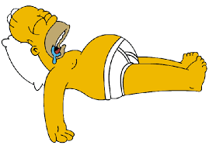](http://images.google.co.uk/imgres?imgurl=http://www.stationnight.com/Homer-Sleep1.gif&imgrefurl=http://mulderfox.blogspot.com/2008/04/sleep.html&usg=__zJ-WsddUfmoaJ8kNWAifLk87q0w=&h=418&w=600&sz=13&hl=en&start=3&tbnid=XYSRbdVR7Nv0YM:&tbnh=94&tbnw=135&prev=/images%3Fq%3Dsleep%26gbv%3D2%26hl%3Den)

**HARDER**

Perform with more resistance

**EASIER**

Perform with no equipment

[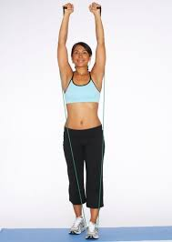](http://images.google.co.uk/imgres?imgurl=http://static.howstuffworks.com/gif/shoulder-exercises-19.jpg&imgrefurl=http://health.howstuffworks.com/shoulder-exercises1.htm&usg=__ClGwGkVgcOON5oVTYMtnH7qonLE=&h=563&w=400&sz=29&hl=en&start=14&tbnid=8IIh5MPbnX6OwM:&tbnh=133&tbnw=94&prev=/images%3Fq%3Dshoulder%2Bresistance%26gbv%3D2%26hl%3Den)

*2*

*SHOULDERS*

*LOWER SHOULDER RESISTANCE*

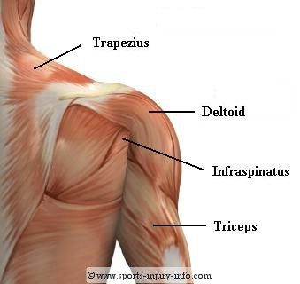

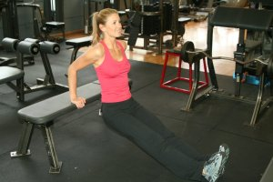

*3*

*BACK OF ARMS*

*TRICEP DIPS*

[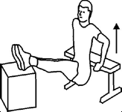](http://images.google.co.uk/imgres?imgurl=http://www.getfit.com.au/html/excercises/images/ex-arms-free-03.gif&imgrefurl=http://www.getfit.com.au/html/excercises/arms.html&usg=__z1sZNg_9gwlhcvtNop85wmkO5lc=&h=150&w=164&sz=7&hl=en&start=4&tbnid=n0oJ5s_prW71KM:&tbnh=90&tbnw=98&prev=/images%3Fq%3DTricep%2Bdips%26gbv%3D2%26hl%3Den)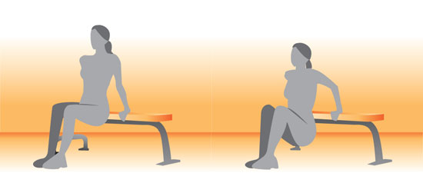

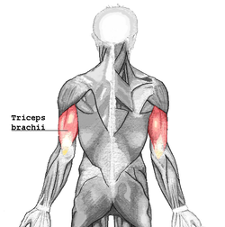

**EASIER HARDER**

**HARDER**

Use bosu or bench

**EASIER**

Use hands on floor to help with lift

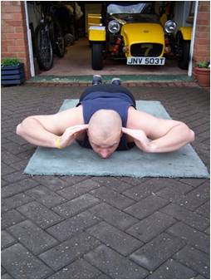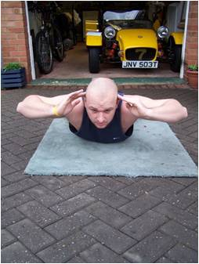

*4*

*BACK*

*SEAL LIFTS*

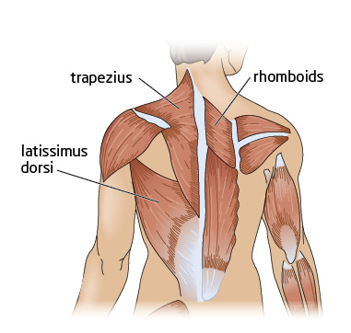

**HARDER**

Lift legs onto bench/step or hold medicine ball in hands

**EASIER**

Hands onto knees, with smaller movements

*5*

*ABDOMINALS*

*SIT UPS*

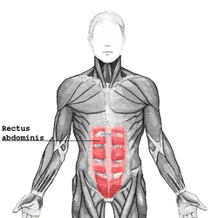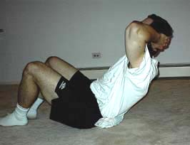

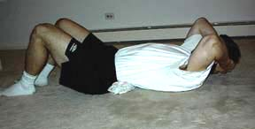

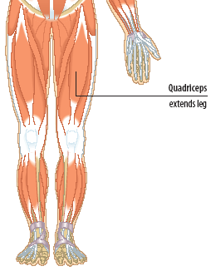

**EASIER**

Make smaller lunge movements (not as low to the floor)

*6*

*UPPER LEGS*

*LUNGES*

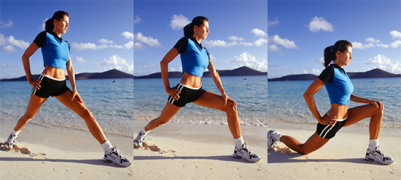

**HARDER**

Hold weights in hands/power bag on shoulder

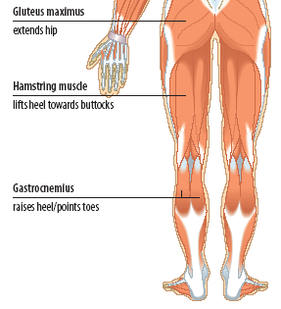

*7*

*LOWER LEGS*

*CALF RAISES*

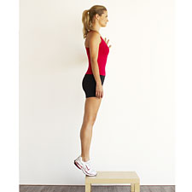

**EASIER**

Produce movement on floor

**HARDER**

Produce movement on bench with weights in hands

**EASIER**

Swing skipping rope by side with one hand while jumping

**HARDER**

Faster skipping with two footed jumps

*8*

*CARDIOVASCULAR*

*SKIPPING*

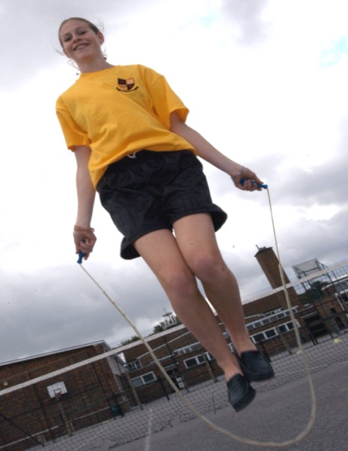



**EASIER**

Box step on floor

*9*

*LOWER LEG*

*STEP UPS*

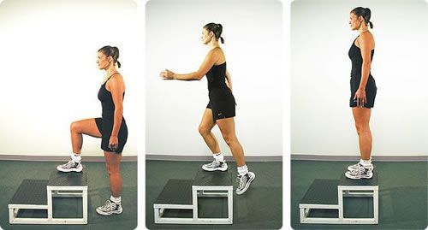

**HARDER**

Perform with weights in hands



**EASIER**

Perform with no weights

*10*

*UPPER LEGS*

*SQUATS*

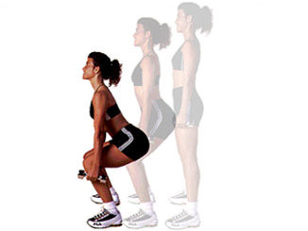

**HARDER**

Perform with heavier weights

**EASIER**

Drop knees to floor or lift backside higher

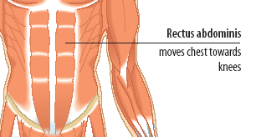

*11*

*CORE STABILITY*

*PLANK*

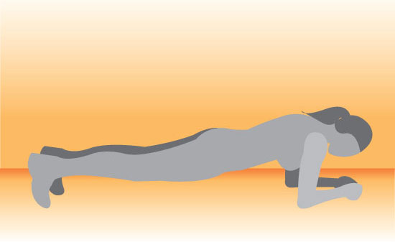

**HARDER**

Perform with a bosu or a Swiss ball

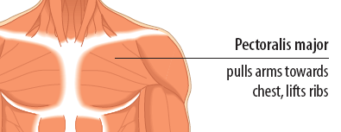

**EASIER**

Drop knees to the floor

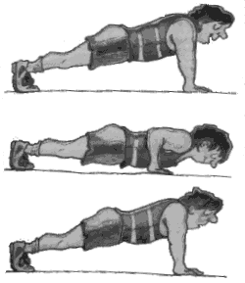

**HARDER**

Lift feet on to bench or clap hands on each lift

*12*

*CHEST*

*PRESS UPS*

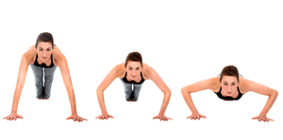

**EASIER**

Perform with no weights

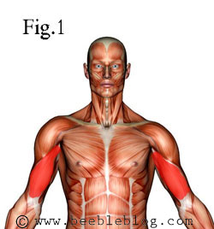

*13*

*FRONT OF ARMS*

*BICEP CURLS*

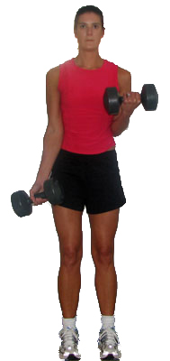

**HARDER**

Perform with heavier weights

**HARDER**

Perform with heavier weights

**EASIER**

Perform with no weights

*14*

*SHOULDERS*

*DUMBELL RAISES*

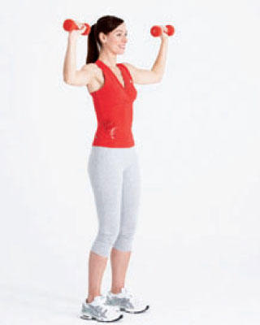

**MUSCLE HEALTH CIRCUIT**

**1. HEAD**

REST STATION

**6. UPPER LEGS**

LUNGES

**7. LOWER LEGS**

CALF RAISES

**5. ABDOMINALS**

SIT UPS

**4. BACK**

SEAL LIFTS

**11. CORE MUSCLES**

PLANK

**14. SHOULDER**

HIGH RESISTANCE SHOULDER PRESS

**2. SHOULDER**

LOW RESISTANCE SHOULDER PRESS

**3. BACK OF ARMS**

TRICEP DIPS

**13. FRONT OF ARMS**

BICEP CURLS

**8. CARDIOVASCULAR**

SKIPPING

**9. LOWER LEGS**

STEP UPS

**10. UPPER LEGS**

SQUATS

**12. CHEST**

PRESS UPS