Introduce myself

1. Review safety rules & basic procedures
2. Briefly cover behavior expectations
3. Discuss the big “why” of physical education

Students come into the gym and sit by the whiteboard.

They have to sit in their squads. Squads are written on the board.

Main rule: listen when the person whose turn it is to talk is talking (be it the teacher or a classmate)

When the teacher shouts: AND STOP You need to stop whatever you are doing and sit down.

(show them the template about rules and procedures)

Time to practice. Play the game Everyone’s IT Frozen tag.

1. Avoiding Opponents in the area
2. Everyone’s IT Frozen Tag (when tagged you freeze. You can join if someone gives you 3x high five in a row)
3. Auto defrost (takes too long to join again, go outside the area, 3 push ups and join again\
4. Static bases (Hoops/mattrasses ) where you’re free for 5 sec (you can’t wait for someone 5 sec)
5. Dynamic bases (bouncing one foot for 5 sec)

During the game you shout: AND STOP a couple of times to find out if the students understood the rule….

1. Behaviour expectations: toilet and changing room rules.
2. The WHY of PE (show poster)

Show the students a youtube video like Max your days from the north face.

WHY? “to empower my students to live as many adventures as possible in life”. As a class, discuss how adventure can represent different things to different people. For some it can mean sandboarding down a volcano, to others, it could mean competing in a big hockey competition you’ve trained for.

What matters isn’t the what of your adventures, but the why: that you have dreams that motivate you to live a life that is rich, full and fun. Together with your class mates. Learning new things, crossing boundaries, gaining self-esteem. Discuss in squats.

<https://www.youtube.com/watch?v=L9pb0CyArCQ>

You can download the number and letter based colourful squad spots at the attachement to this lesson.

**To help make my classroom management more efficient, I decided to use a squad system with my younger grades. Part of our classroom routines involves the students sitting down in their squads at different moments throughout the lesson. Since I often need my students to “squad up” at different locations in the gym (e.g. in front of the TV so we can analyze a skill performance, in front of the whiteboard so we can go over the lesson’ What/Why/How, or at their cones so that we can get into a peer-assessment activity), I decided to create two different versions of each squad’s colourful squad spot: a letter-based one and a number-based one. This way, I can have my students learn the routines of “squadding up” at their number spots or their letter spots.**

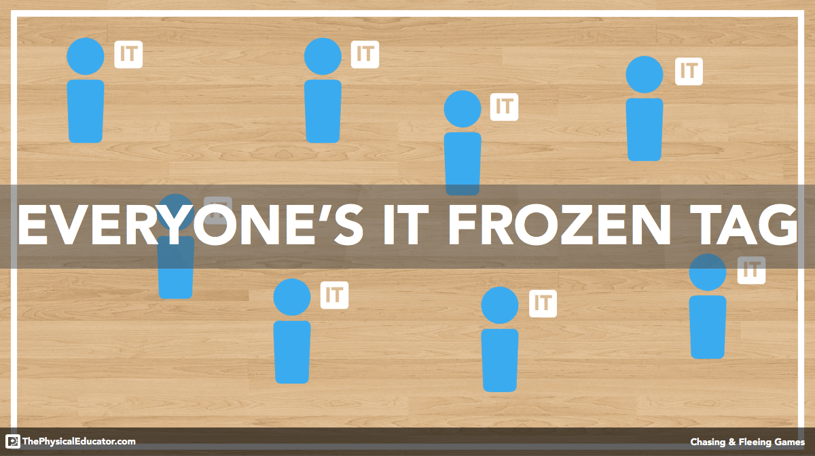

CLIL

Introducing the WHY of Physical Education

PE helps us get the most out of life….

**How to start my schoolyear**

**Instruction**

**Title**

**Lessen Goal**

**QR code**

**Link to assessment document**

**Type**

**Field set-up**

