
Title: Push up
Type: athletics, warming up, bootcamp
Lesson Goal: 3 levels of push ups

Instruction | Differentiation options | Extra info
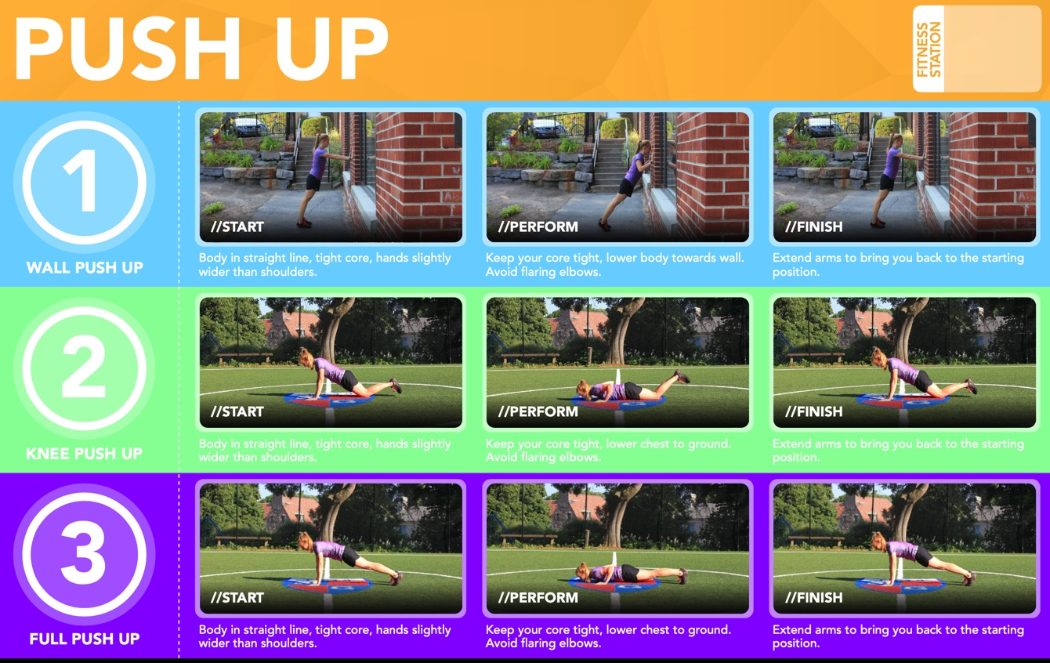
Field set-up:

Link to support/assessment document: www.thephysicaleducator.com

Additional pages if necessary:

