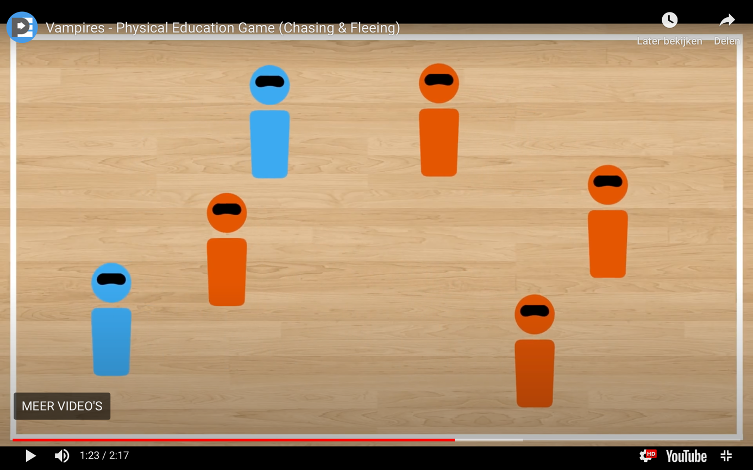

Vampires is a fun blindfold game that is a blast to play at this time of the year. As with all blindfold games, make sure you make your safety guidelines very clear and get ready for some screams, laughs, and fun!

Credits go to thephysicaleducator.com

Click at the link below to find the video including explanation:

<https://thephysicaleducator.com/2012/10/30/halloween-games-for-physical-education/?ct=t(The_PhysEd_Newsletter_2_0_0022_4_2017_COPY_02)&mc_cid=668e81950a&mc_eid=d4a1622529>