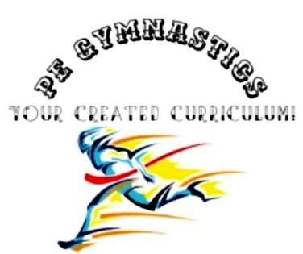
Title: WhAT Great Coaches Do
Type: CLIL
Lesson Goal: Words you can use, coaching, general

Instruction | Differentiation options | Extra info
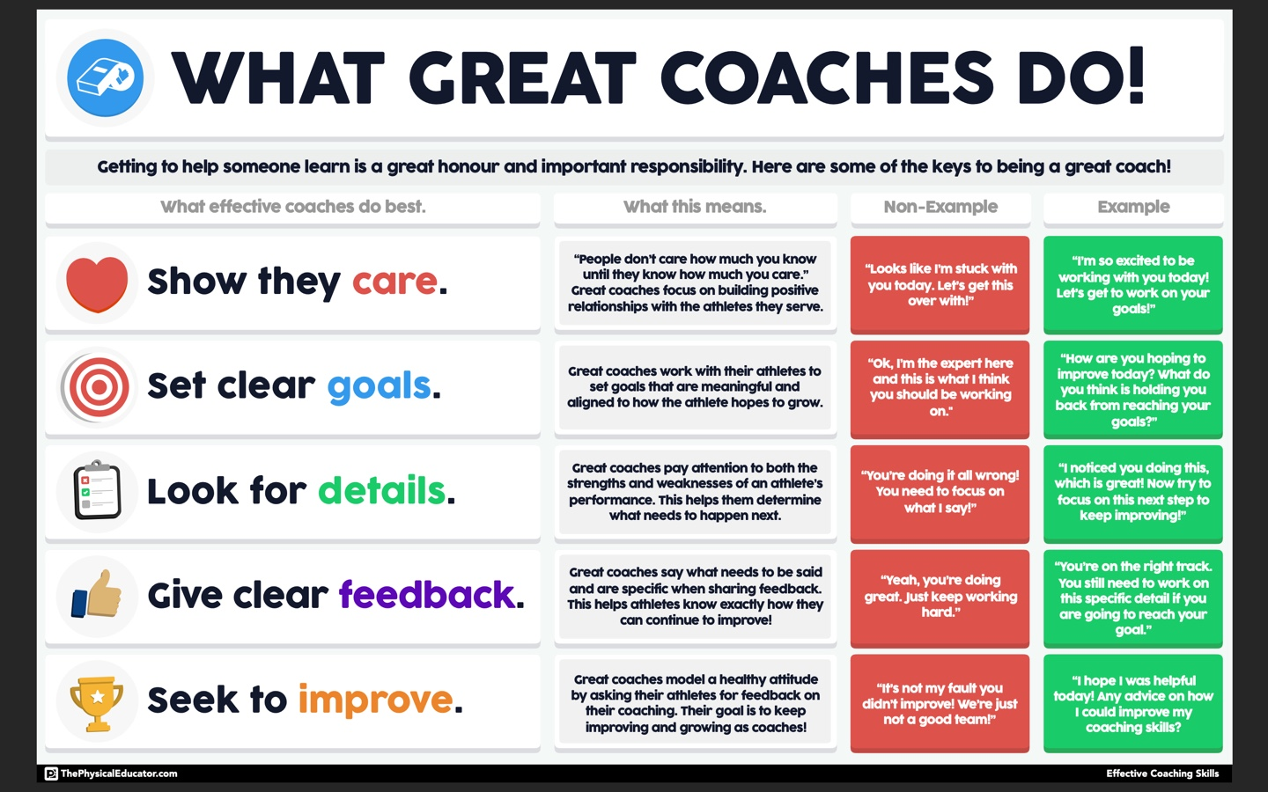 | This picture gives you some general things to say to students.
Field set-up:

Link to support/assessment document

Additional pages if necessary:

