1. Divide the class in groups of four.
2. Place the assignments upside down on the floor on the other side of the gym.
3. Number 1 has to run to one of the papers read the paper and run back to his/her teammates. He/She explains the assignment. The whole group has to do the assignment. Once they are done another team member runs to the other side of the gym and reads the next assignment.
4. (Take care of each other, it can be crowded in the gym)

Do 20 sit ups somewhere in the gym.

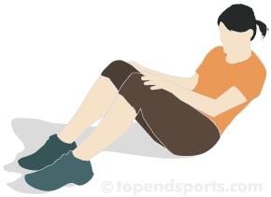

Go to one of the benches and do 20 step ups.

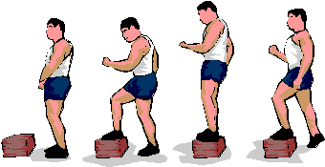

Pair up in your group. Fetch a volleyball and throw it ten times to each other.

Pair up

Pair up in your group. Get a tennisball. Throw the ball against the wall. Your buddy has to catch the ball. Do this 10 times.



Pair up

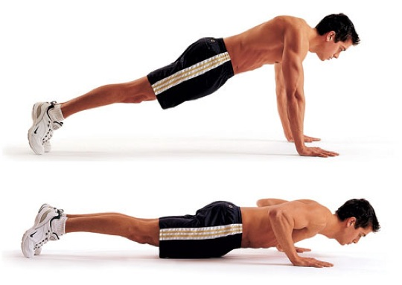Do 10 push ups somewhere in the gym.

Hop to the other side of the gym. Hop back with your other leg.

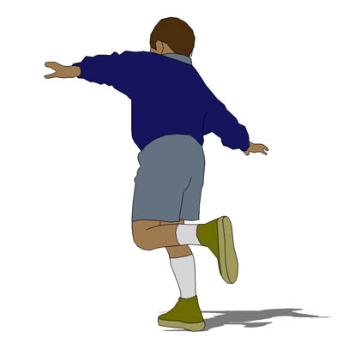

Skip to the other side of the gym and skip back.

[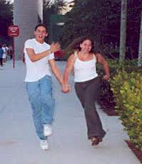](http://www.google.nl/imgres?start=91&biw=1280&bih=843&tbm=isch&tbnid=vk0e70K8eI6bkM:&imgrefurl=http://www.noelkingsley.com/blog/archives/2008/01/skipping.html&docid=Md4zamAiEU1y2M&imgurl=http://www.noelkingsley.com/blog/carl_and_sara_skipping.jpg&w=250&h=289&ei=-GyfUfqAHaqO0AX62YGgDw&zoom=1&iact=hc&vpx=748&vpy=493&dur=874&hovh=231&hovw=200&tx=77&ty=170&page=3&tbnh=141&tbnw=135&ndsp=51&ved=1t:429,r:22,s:100,i:70)

|  |  |  |
| --- | --- | --- |
| Groupmembers: |  | Points |
| How many activities did you do? |  |  |
| Did you speak English all the time? |  |  |
| Write down some expressions you used? | 1.  2.  3.  4.  5. |  |
| Write down some of the phrases you used? | 1.  2.  3.  4.  5. |  |