**Observation Form Sprint Class 2**

Sprinter: ­­­­­­­­­­­­­­­­­­­­_______________________ Observer:_______________________

|  |  |  |  |  |  |
| --- | --- | --- | --- | --- | --- |
| **“On your marks”** | **--** | **-** | **+/-** | **+** | **++** |
| 1. Toes against the blocks. |  |  |  |  |  |
| 1. Fingers parallel to the starting line, fingers don’t touch the line. |  |  |  |  |  |
| 1. Arms extended and at shoulder width. |  |  |  |  |  |
| 1. Sprinter looks at the track 1 meter ahead of him. |  |  |  |  |  |

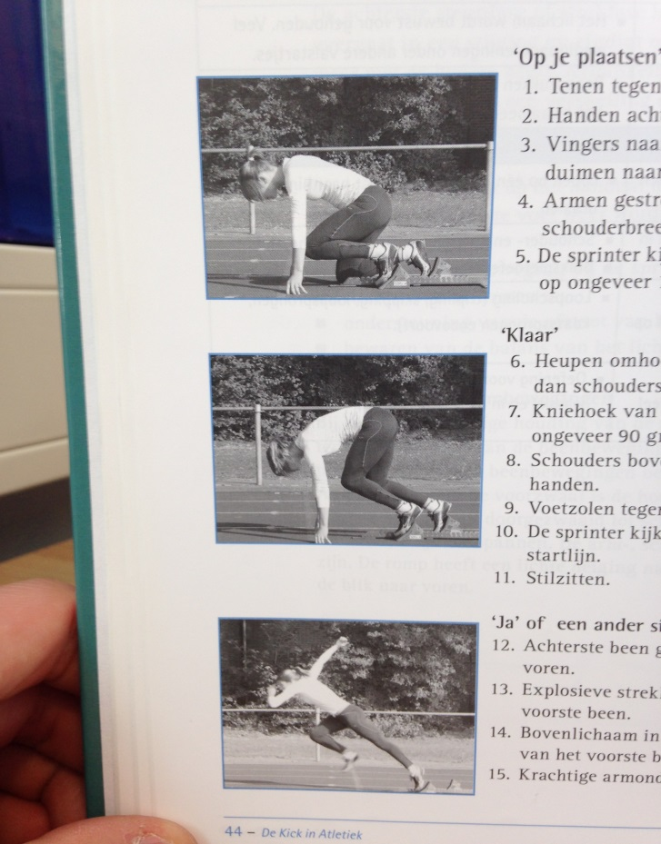

Tips:

1. ___________________________________________________________________________________

2. ___________________________________________________________________________________

Tops:

1. ___________________________________________________________________________________

2. ___________________________________________________________________________________

|  |  |  |  |  |  |
| --- | --- | --- | --- | --- | --- |
| **“Set”** | **--** | **-** | **+/-** | **+** | **++** |
| 1. Hips go up, slightly above shoulder level. |  |  |  |  |  |
| 1. The angle in the first knee is about 90 degrees. |  |  |  |  |  |
| 1. Sprinter looks at the starting line. |  |  |  |  |  |
| 1. Sprinter stays still. |  |  |  |  |  |

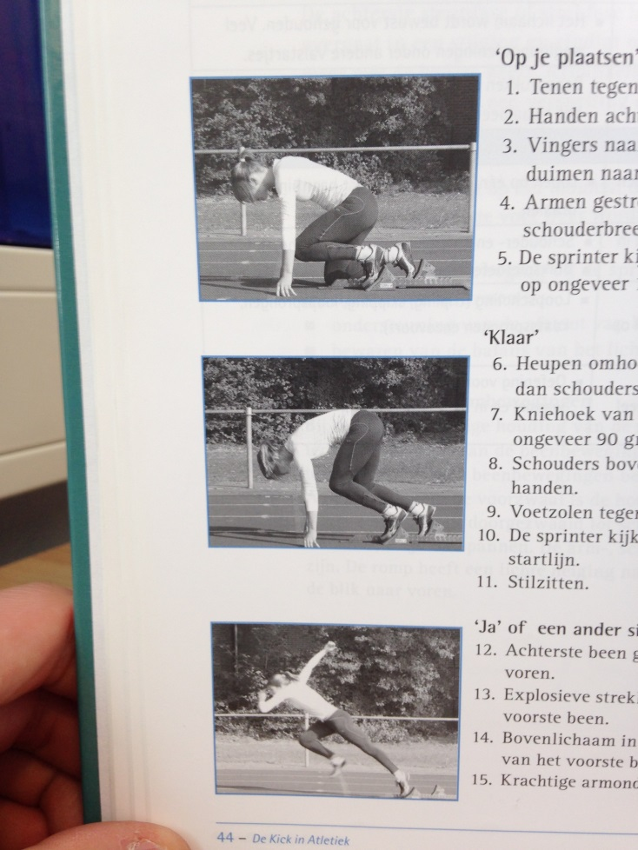

Tips:

1. ___________________________________________________________________________________

2. ___________________________________________________________________________________

Tops:

1. ___________________________________________________________________________________

2. ___________________________________________________________________________________

|  |  |  |  |  |  |
| --- | --- | --- | --- | --- | --- |
| **“GO!”** | **--** | **-** | **+/-** | **+** | **++** |
| 1. The leg that’s behind quickly shoots to the front. |  |  |  |  |  |
| 1. Explosive stretch of the first leg. |  |  |  |  |  |
| 1. Torso is an extension of the first leg. |  |  |  |  |  |
| 1. Powerful arm support. |  |  |  |  |  |

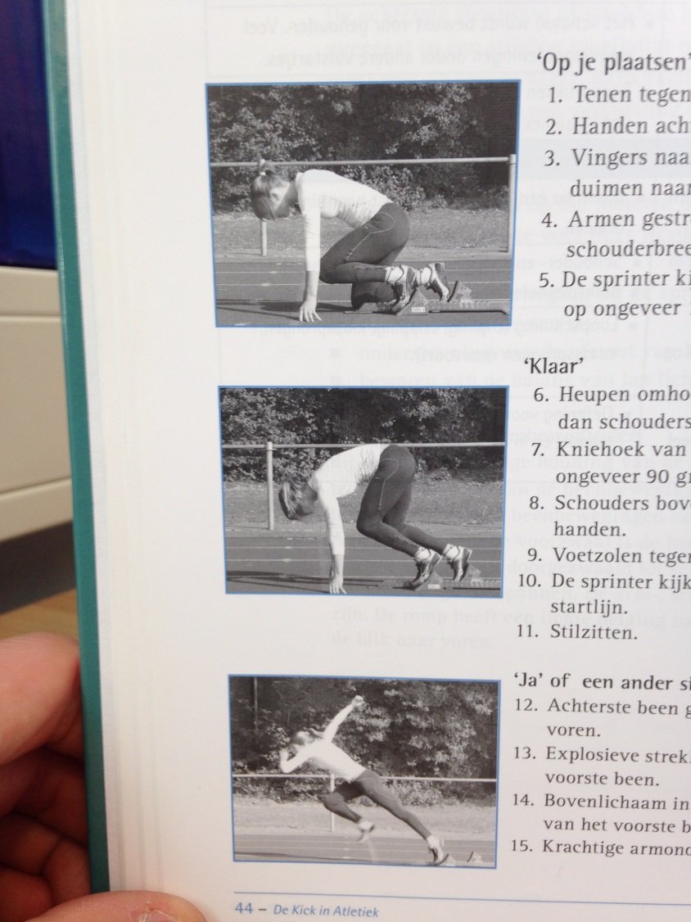

Tips:

1. ___________________________________________________________________________________

2. ___________________________________________________________________________________

Tops:

1. ___________________________________________________________________________________

2. ___________________________________________________________________________________

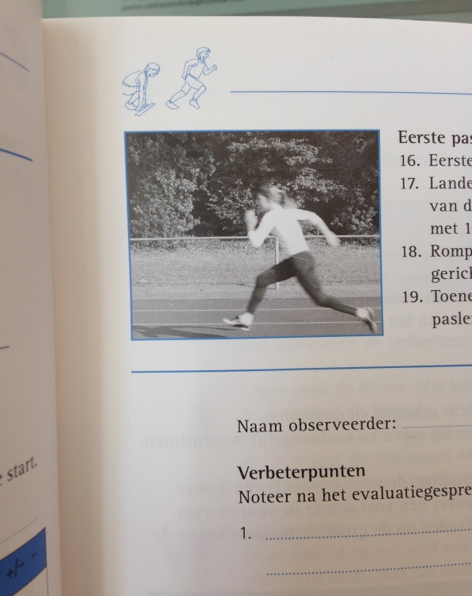

|  |  |  |  |  |  |
| --- | --- | --- | --- | --- | --- |
| **First sprint phase** | **--** | **-** | **+/-** | **+** | **++** |
| 1. First steps are short and fast. |  |  |  |  |  |
| 1. Land and take off on the ball of the foot. |  |  |  |  |  |
| 1. Torso is bended in a forward motion. |  |  |  |  |  |
| 1. Increasing cadence and length of the steps. |  |  |  |  |  |

Tips:

1. ___________________________________________________________________________________

2. ___________________________________________________________________________________

Tops:

1. ___________________________________________________________________________________

2. ___________________________________________________________________________________