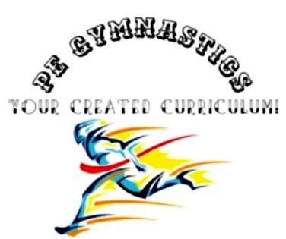
Title: Plank
Type: Clil, warming-up, bootcamp
Lesson Goal: Learn the proper technique of the plank

Instruction | Differentiation options | Extra info
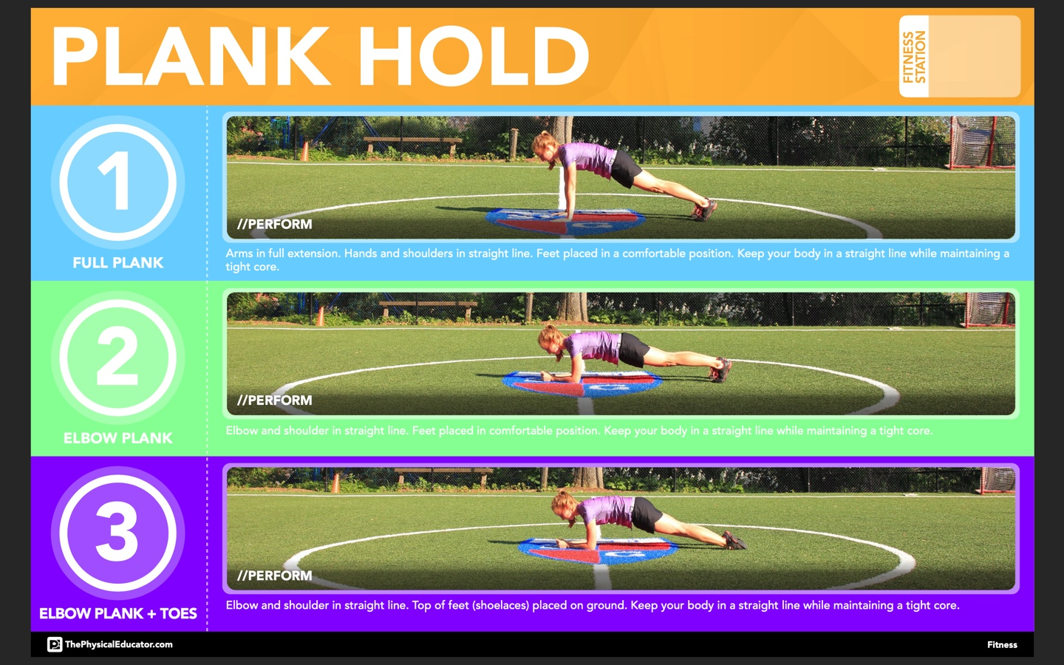
Field set-up:

Link to support/assessment document: www.thephysiacaleducator.com

Additional pages if necessary:

