**Fitness Bingo**

**EQUIPMENT:** fitness bingo cards (1 per student), teacher bingo cards (to draw from), fitness posters, and activity information, pencils

**PLAYING AREA:** gymnasium

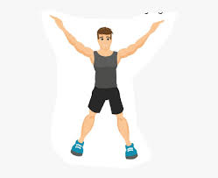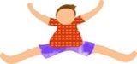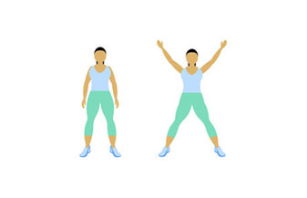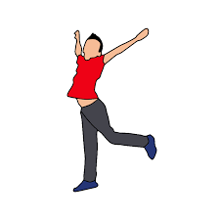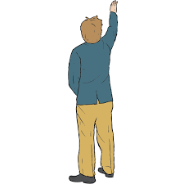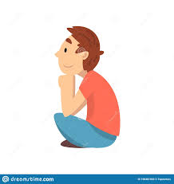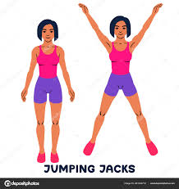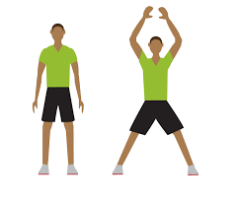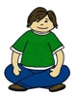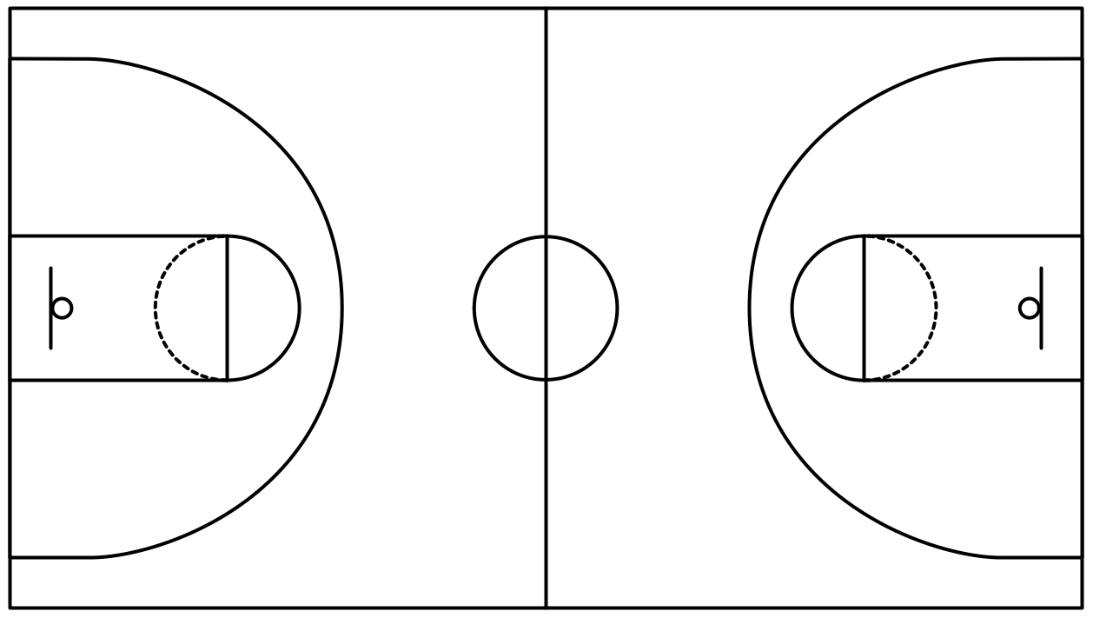

**SET-UP:**

* Photocopy a bingo card for each student. There are 32 different cards.
* Photocopy and display fitness posters. These briefly explain the various activities.
* Photocopy and cut out the teacher cards. These will be drawn randomly to determine the order of the fitness activities.
* Make sure that every student has a pencil to mark off completed squares on their bingo card.

**OBJECTIVE:**

* The objective is to complete any three lines on your bingo card and to get exercise.

**RULES:**

* The teacher will draw a fitness activity card.
* If you have that exercise on your bingo card, do the exercise and then cross it out on your bingo card.
* The first person to complete three lines wins.

**GAME VARIATIONS:**

* Instead of needing three lines to finish, play blackout bingo, any 3x3 square, or a different number of lines to win.
* Adjust the number of repetitions needed for younger grades.

**FITNESS BINGO**

**FITNESS POSTERS**

|  |
| --- |
| Stand On One Foot Clipart, HD Png Download , Transparent Png Image ...  **BALANCE ON LEFT FOOT**  From a standing position, lift your right foot off the floor and hold your balance for 15 seconds. |
| 6 SIMPLE EXERCISES WITH BALANCE PAD YOU CAN DO AT HOME - Yes4All ...  **BALANCE ON RIGHT FOOT**  From a standing position, lift your left foot off the floor and hold your balance for 15 seconds. |
| Biceps Curl  **BICEP CURLS**  Start with your arms extended at your sides. Bend your elbows and bring your hands toward your chin. Do 10. |
| Girl doing ab bicycle exercise - Download Free Vectors, Clipart ...  **BICYCLE EXERCISE**  Lay with your back on the floor. Use your legs to bicycle in the air. Do this for 15 seconds. |
| This Is What Happens When You Do 30 Burpees Every Day for 15 Days  **BURPEES**  Do this rotation of five movements- squat, jump in the air, squat, extend legs, do a push-up. Do 5. |
| How To Do Calf Raises and Variations | Openfit  **CALF RAISES**  Stand up facing a wall. Lift your heels off the ground and then bring them down again. Do 10. |
| Crab Walk exercise diagram, arm, personal fitness workout | Gym ...  **CRABWALK**  Use all four limbs to move around while your tummy is facing the roof. Do this for 15 seconds. |
| Free Crunches Cliparts, Download Free Clip Art, Free Clip Art on ...  **CRUNCHES**  Lay on your back. Bend your knees and put your hands behind your head. Lift your head slightly until you feel it in your abs. Do 10. |
| Dance Silhouette Free Stock Photo - Public Domain Pictures  **DANCE ON THE SPOT**  Dance on the spot for 15 seconds. |
| Forward Lunge - DIME Injury Prevention  **FORWARD LUNGES**  Match your body position to the man in the picture. Your front knee should be at a 90° angle. Do 5 on each leg. |
| Grapevine eller Grapewine: Hvad hedder og betyder det?  **GRAPEVINE**  Walk to the side making sure your legs cross over each other, first in front and then behind. Do 5 steps in each direction. |
| Did you do your Bridges Today?  **HIP BRIDGE**  Lay on your back with your feet flat on the floor. Lift your bottom and hold this position for 15 seconds. |
| Jumping Child Clip Art - Hop On One Foot Clipart, HD Png Download ...  **HOP ON ONE FOOT**  Hop on your right foot 10 times. Then hop on your left foot 10 times. |
| The Inchworm: Core Strength Exercise for Kids - The Inspired Treehouse  **INCHWORM**  Match your body position to the girl in the picture. Walk your feet back to a plank position and then walk them forward to your starting position. |
| How To Do Squat Jumps  **JUMP ON THE SPOT**  Using a two-foot take off and two-foot landing, jump on the spot 10 times in a row. |
| silhouette jumping jacks clipart - Clip Art Library  **JUMPING JACKS**  Start with your feet together and your hands by your side. Extend all four limbs laterally and then back to your starting position. Do 20. |
| Download free photo of Yoga,woman,exercising,exercises,poses ...  **LEG STRETCHES**  Stretch all your leg muscles. Remember your quadriceps, hamstrings, and calves. Stretch for 30 seconds. |
|   **LINE JUMPS**  Jump side to side over a line in your gym. Do 10 jumps altogether. |
| Dance studio - Great Grub Club  **MARCH ON THE SPOT**  March on the spot for 15 seconds. |
| 5 Core-Strengthening Plank Exercises | Washingtonian (DC)  **PLANK**  Balance on your forearms and your toes for 15 seconds. |
| Exercising,practices,sport,gym,man - free image from needpix.com  **PUSH-UPS**  Balance on your hands and toes. Extend your elbows to support your body weight and then flex them to return to your starting position. Do 10. |
| Running on the Spot Girl Pe Kit Illustration - Twinkl  **RUN ON THE SPOT**  Run on the spot for 15 seconds. |
|   **SIDE LEG RAISES**  Lay on your side. Lift your top leg up and then down again. Do 10 on each side. |
| Side Lunge Pulses - Exercise How-to - Workout Trainer by Skimble  **SIDE LUNGES**  Bend one knee and extend the opposite one as you squat down slightly. Do 5 on each side. |
| The Side Plank: Build Endurance in Your Core and Lower Back  **SIDE PLANKS**  Match your body position to the picture and hold for 10 seconds. Do the same on the other side. |
| Sit Ups Stock Photos And Images - 123RF  **SIT-UPS**  Lay on your back, bend your knees, and put your hands behind your head. Lift your upper body until your chest touches your legs. Do 10. |
| Fitness for you - Young World Club  **SQUATS**  Bend your knees and squat down. Hold this position. |
| Squat Jump | The Best Cardio Exercises You Can Do in Your Living ...  **SQUAT JUMPS**  Go to a squat position and then jump as high as you can in the air. Do 10. |
| Superman Exercise Tutorial - Bodyweight Exercises - Fitstream  **SUPERMAN POSE**  Lay on your tummy and left all four limbs. Do NOT bend your knees or elbows. Hold for 15 seconds. |
| toe touches clipart - Clip Art Library  **TOE TOUCHES**  Without bending your knees, touch your toe with the opposite hand. Do 5 on each side. |
| 5-Minute Tabata Fat Burning Routine - That Old Millennial  **TUCK JUMPS**  Jump in the air and try to make your knees touch your chest. Do 10. |
| 30 Day Wall Sit Challenge – Say Yes to Happy  **WALL SIT**  Put your back against the wall and lower your body until your knees are at a 90° angle. Hold for 20 seconds. |

**TEACHER CARDS**

**TEACHER CARDS**

**TEACHER CARDS**

**FITNESS BINGO CARDS 1-4**

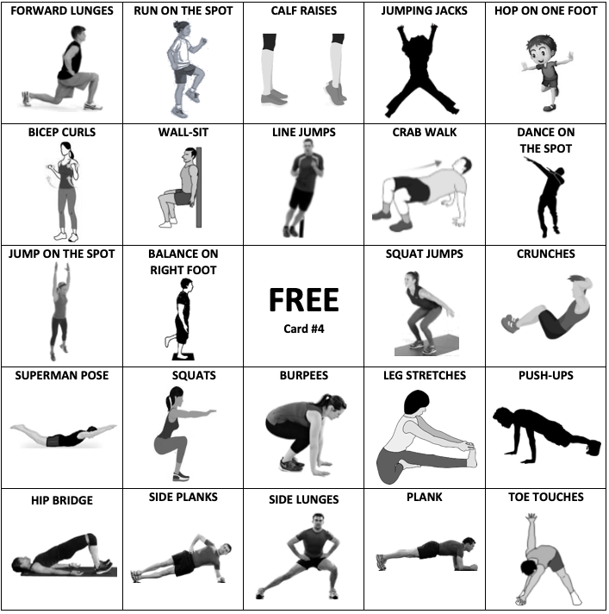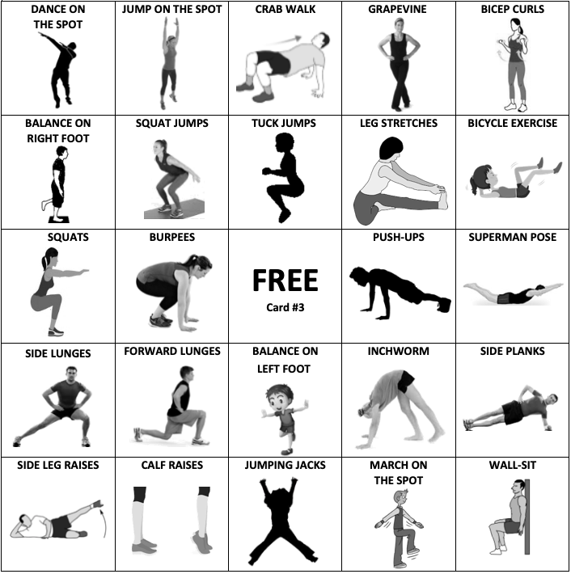

**FITNESS BINGO CARDS 5-8**

**FITNESS BINGO CARDS 9-12**

**FITNESS BINGO CARDS 13-16**

**FITNESS BINGO CARDS 17-20**

**FITNESS BINGO CARDS 21-24**

**FITNESS BINGO CARDS 25-28**

**FITNESS BINGO CARDS 29-32**

