**Title: Vaulting**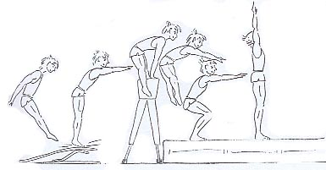  
  
**Type:** Spread jump, Crouch jump  
**Lesson Goal:** Jump over the vault with a spread and a crouch jump



|  |  |  |
| --- | --- | --- |
| **Instruction** | **Differentiation options** | **Extra info** |
| **Learning goals** You are able to:   1. Walking up to the jump platform/ (reutherplank) at a good pace. 2. Jumping with two feet simultaneously on the board; 3. After the jump floating in the air to the support, horse; 4. Putting your hands on the horse; 5. Floating for a second time by elevating from the horse; 6. Landing safely after the second floating phase; 7. Learning to catch a person in a spread jump, crouching jump.   **Helping** You are able to :   * Standing behind the horse and catching the upper arms when the person does a crouch jump. * Standing behind the horse and catching someone by the upper arm when that person does a crouch jump.   **Important points** You are able to:   * Run to the horse fast and fluent; * Jump with two feet at the same time on the board; * Floating from the board to the horse; * Supporting on the horse and floating from the horse; * Crouch over the horse; * Spread over the horse; * Making a stabile landing. | Jump over the horse with 1,2,3,4 or 5 clicks  Differentiate the distance  Give opportunity to land on top (with crouch jump) | Afbeelding met pentekening  Automatisch gegenereerde beschrijvingAllround blz 186 AAllround blz 186 A |
| Instructions for the vault  * Run quickly to the jump board; * Jump well before the board (less distance than with a trampoline); * Place your feet twenty centimetres before the end of the board; * Jump flat and wave your arms forward; * Make short intense contact with the board; * With the landing go through your knees and keep your hands in front of you..  Spread jump over the horse Crouch jump over the closet (broad)  |  |  | | --- | --- | | * Accent on the first floating phase * Helping: quickly hold the upper arms while supporting on the horse and walk with the jumper backwards. | * Hands quickly to the closet and push the closet from under you. Shoulders go up. * In the second floating phase take your hands forward. * Helpers on both sides holding the arms while supporting. |  Spread jump over the length of the closet Crouch jump over the length of the closet  |  |  | | --- | --- | | * Place hands far backwards * Short intense touch with the closet * One helper holds the upper arms and walks backwards with the jumper. | * Place hands far backwards * Kick your heels up * Intense kick off with the hands and crouch the legs. | |  |  |
| **Field set-up:** | | |
| **Link to support/assessment document** | | |

**Additional pages if necessary:**