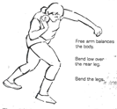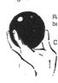**SHOT PUT CHECK SHEET**

 Key points when assessing my partner. Do they…

1) Have shot put under jaw and on neck

2) Hold shot with dirty fingers, clean palm

3) Positioned sideways on

4) Bend knees with weight forwards, ‘chin, knee, toe’

5) Twist hips round, swing arm round and push low to high

6) Push shot explosively upwards and forwards

7) Keep elbow high and follow through

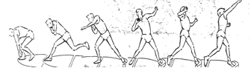My partner scored……out of 7

Their strong points were………….

They need to work on…………….

**SHOT PUT CHECK SHEET**

 Key points when assessing my partner. Do they…

1) Have shot put under jaw and on neck

2) Hold shot with dirty fingers, clean palm

3) Side sideways on

4) Bend knees with weight forwards, ‘chin, knee, toe’

5) Twist hips round, swing arm round and push low to high

6) Push shot explosively upwards and forwards

7) Keep elbow high and follow through

My partner scored……out of 7

Their strong points were………….

They need to work on…………….

**SHOT PUT CHECK SHEET**

 Key points when assessing my partner. Do they…

1) Have shot put under jaw and on neck

2) Hold shot with dirty fingers, clean palm

3) Side sideways on

4) Bend knees with weight forwards, ‘chin, knee, toe’

5) Twist hips round, swing arm round and push low to high

6) Push shot explosively upwards and forwards

7) Keep elbow high and follow through



My partner scored……out of 7

Their strong points were………….

They need to work on…………….

**SHOT PUT CHECK SHEET**

 Key points when assessing my partner. Do they…

1) Have shot put under jaw and on neck

2) Hold shot with dirty fingers, clean palm

3) Side sideways on

4) Bend knees with weight forwards, ‘chin, knee, toe’

5) Twist hips round, swing arm round and push low to high

6) Push shot explosively upwards and forwards

7) Keep elbow high and follow through

My partner scored……out of 7

Their strong points were………….

They need to work on…………….