Ed Leegwater
RSG Broklede

Basic Rules Softball

Well, to be honest, the best way to learn the rules of softball is to actually play the game. Until you're actually playing a game, whatever rules we throw at you is something akin to mumbo-jumbo but it all tends to fall into place once the game gets going. However, I'll just put some basic rules here to help, since we've been making our players play plenty of games - so hopefully, it should make vague sense...
Batting
Each batter gets four balls and three strikes (a ball being a bad pitch, a strike being a good one). If a batter swings for the pitch, it will be called a strike, regardless of whether it was a ball or strike. The on-deck batter (batter waiting to hit) must not enter the field of play until the play resulting from the previous batter has finished.
Base running
Once the batter reaches first base, s/he is then called a base runner. You are not obliged to get round all in one go to score - any runner passing home will score, even if s/he has stopped on every single base. You MUST touch ALL of the bases as you go round.
The base runner must not deviate from his/her natural running path to avoid a tag, doing so results in the base runner being called out. If the ball is caught off the bat, the batter is called out and base runners have to return to their previous bases.
Pitching
The pitcher must begin the pitch with one foot on the pitching rubber.
For a pitch to be called a strike it must be above the (home)plate between the batter's knees and shoulders. Anything else will be called a ball.
Fielding
When the fielding side scores three outs, the teams switch over.
You get an out when the batter strikes out, the ball is caught off the bat, the runner is forced out at a base or the runner is tagged. To force a runner out at a base, the runner must be forced to the next base i.e. the batter is forced to run to first base when s/he hits the ball and if there is anyone on first base, then s/he will be forced to second etc. To force a runner out, the ball must reach the base before the runner and the base player must have control of the ball and must be in contact with the base. It is not necessary to "stump" the base with the ball.
To tag a runner out, all you need to do is touch the runner with the ball or the glove with the ball in it.
If a runner is not forced, s/he MUST be tagged in order to be called out.
If the ball is overthrown and goes dead, the runners are awarded TWO bases from the last base touched at THE POINT OF THE THROW. This one's important!
The ball can be caught and an out made if the ball is hit foul.
Once the ball is caught in foul, the batter is called out and the ball is dead.

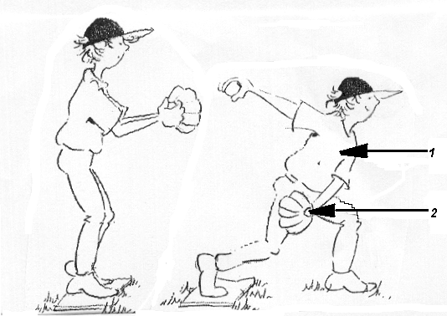
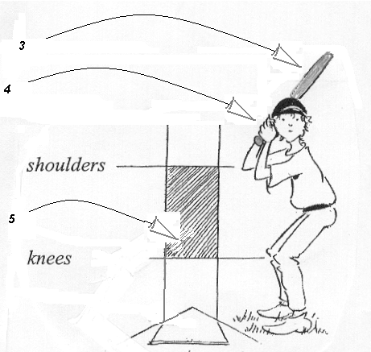
1
2
3
4
5

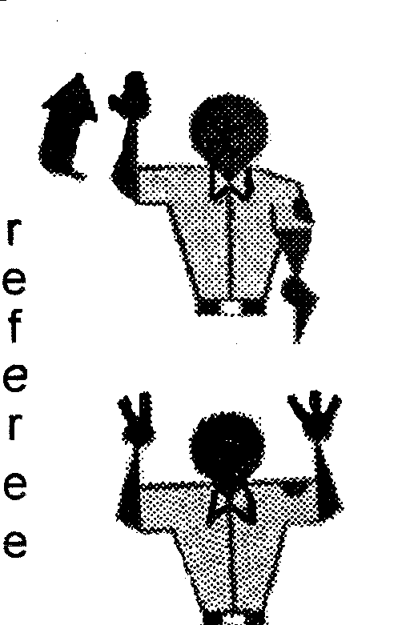

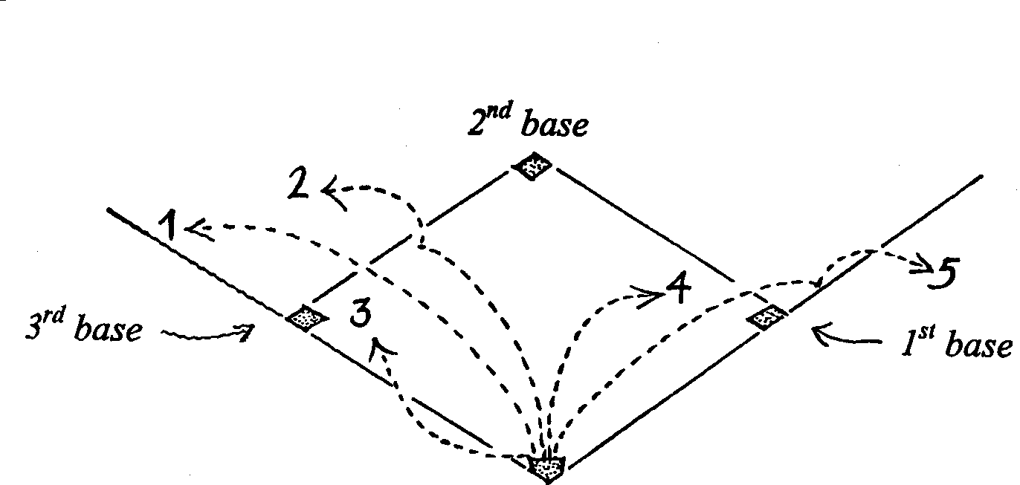
Are these balls fair or foul?
Ball 1 fair/foul
Ball 2 fair/foul
Ball 3 fair/foul
Ball 4 fair/foul
Ball 5 fair/foul

