Christmas song dance 2022
Class 1 and 2

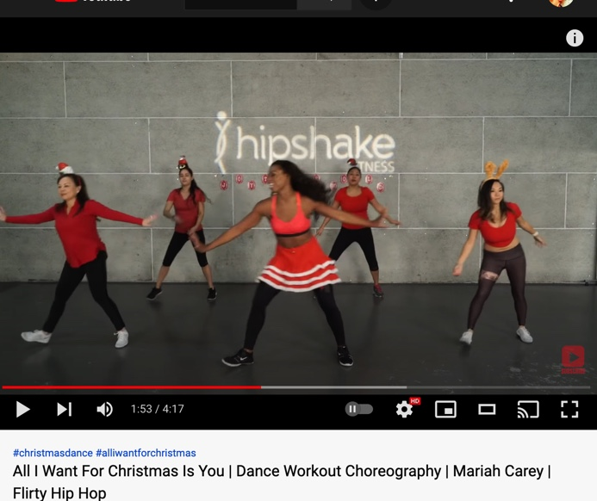
Dance assignment Christmas dance
Watch the next link:
https://www.youtube.com/watch?v=ZzeExL10fTg
Practice at home already. We won’t perform the whole dance, but we will start at 1.02 and finish at 1.35.
After that it’s up to you (with a group) to come up with at least 6x 8 seconds to finish the dance in your own way until you get to the next chorus and repeat the chorus.

Nice ideas to learn steps:
https://www.youtube.com/watch?v=tXw8eLrnYmU https://www.youtube.com/watch?v=7eAaInwFSn0 https://www.youtube.com/watch?v=GZVG3QB-2pU https://www.youtube.com/watch?v=1ItXy5_jY0E https://www.youtube.com/watch?v=5W4pfqGybio
Or just look it up at Youtube.
During the warming up each lesson, I will teach you some steps too. You could use these steps as well if you like.

Lesson 1: week 47, week of nov 22)
Exlanation dance, start basic steps and creating groups in the class

Lesson 2: week 48, week of nov 29)
extra long warming up, provide and learn new steps,, practice the chorus with your own group and make it perfect at the same time.

Lesson 3: week 49, week of dec 6)
Repeat dance, practice new steps, come up with nice new ideas, lots of time to practice with the group and come up with the 6x8 seconds and finish up the dance.

Lesson 4: week 50, week of dec 13)
repetition, repetition, repetition. Make sure the dance is finished and everything is synchronized. Finish up and agree on what clothes to wear and what props you need.

Lesson 5: week 51, week of dec 20)
Perform your dance in front of the group. If you rather don’t want that, you can also film it and sent it to me so I can give you marks for it. You will receive two marks. One for the final result, and one for your own performance. This own performance has to do with your attitude last couple of weeks: did you work together ,did you take initiative, did you come up with nice ideas etc. Together these 2 marks will become 1 final mark.

Example Christmass dance 2020:
If you click on this link, you can watch a video of a performance from a first class in 2020. You can see the chorus and then their own choreography. It’s a nice example.
https://vimeo.com/648971626

