SWINGING IN HANGING POSITION

Learning goals You are able to:
- Put the rings at the correct height for a good swing;
- Swinging higher at every swing;
- Thrusting up with two feet rythmically;
- Deciding what the stationary point in the swing is;
- Swinging back and fourth at least three times
- Jumping off in the back swing to a solid landing.

Helping You are able to:
- Catching a student by holding him/her by chest and back
- Helping your teammates when it comes to filling out the form.

Important points You are able to:
- Make every swing higher;
- Rythmical push off at the stationary point;
- ‘Shape your body like a banana at stationary point in front and back swing;
- Jump off at stationary point to a solid landing.

Test In the lesson:
- By the teacher;
- Evaluating the progress.

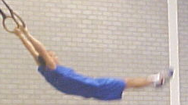
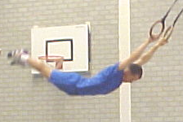
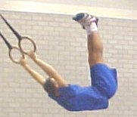
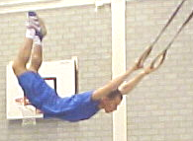

Good front swing

Good back swing

Wrong

Wrong

Helping
- Stand with two helpers so that the swinger can swing in beteen you. The helpers say when the swinger is at his/her stationary point and can let go.
- You grab the swinger out of the air as soon as possible. Grab the swinger by the chest and back until he/she is safe on the mat.

Observing:
You work in groups of fours. With two you look at a fellow student. You score after the exercise. Look at the total movement. If everybody watches two points it has to work just fine. Every exercise can have a maximum of six swings.

JUDGING RINGS SWING

Besides myself my group consists of:
1. | 2. | 3.

Look at the swinging student and cross what is true:
 | Les 1 |  |  | Les 2 |  |  | Les 3
Does he/she swing higher every swing? | I | S | E | I | S | E | I | S | E
Is the push-off with two feet after another? | I | S | E | I | S | E | I | S | E
Does the one swinging jumps out at the right time? | I | S | E | I | S | E | I | S | E

 | Lesson 1 | Lesson 2 | Lesson 3
What is the position in the front swing:  Draw the position ⇒ | I S E  (Circle) | I S E  (Circle) | I S E  (Circle)
 | Lesson 1 | Lesson 2 | Lesson 3
What is the position in the back swing:  Draw the position ⇒ | I S E | I S E | I S E
 | Lesson 1 | Lesson 2 | Lesson 3
What is the position in the descent:  Draw the position ⇒ | I S E | I S E | I S E

Form to evaluate one’s own performance

Fill out the lesson using the following questions :

1. | Did I help preparing the lesson or cleaning up afterwards?
2. | Did I stick to the given assignment?
3. | Did I contribute to a good and productive atmosphere?
4. | Did I work hard?
5. | Did I help others where possible (coaching, helping fill out the form etc)?
 | Lesson 1 |  |  |  | Lesson 2 |  |  |  | Lesson 3
 | I  <6 | S  6-8 |  | E  >8 | I  <6 | S  6-8 |  | E  >8 | I  <6 | S  6-8 |  | E  >8
1.
2.
3.
4.
5.
 | Grade for this lesson |  |  |  | Grade for this lesson |  |  |  | Grade for this lesson
 | Final evaluation

+ = : 2 =

Proces Product Final grade:

